## **Week 5 Homework Submission File: Archiving and Logging Data**

Please edit this file by adding the solution commands on the line below the prompt.

Save and submit the completed file for your homework submission.

### **Step 1: Create, Extract, Compress, and Manage tar Backup Archives**

1. Command to **extract** the TarDocs.tar archive to the current directory:

**tar -xvf TarDocs.tar**

1. Command to **create** the Javaless_Doc.tar archive from the TarDocs/ directory, while excluding the TarDocs/Documents/Java directory:

**tar -cvf Javaless_Docs.tar --exclude-tag-under=Java ~/Projects/TarDocs**

1. Command to ensure Java/ is not in the new Javaless_Docs.tar archive:

**tar -tf Javaless_Docs.tar**

**tar -tf Javaless_Docs.tar | grep -rw Java \***

**Bonus**

* Command to create an incremental archive called logs_backup_tar.gz with only changed files to snapshot.file for the /var/log directory:

**sudo tar --listed-incremental=snapshot.file -cvzf logs_backup.tar.gz /var/log**

#### **Critical Analysis Question**

* Why wouldn't you use the options -x and -c at the same time with tar?

**-c Create a new archive. and -x Extract files from an archive. You cannot create a tar file and also extract at the same time.**

### **Step 2: Create, Manage, and Automate Cron Jobs**

1. Cron job for backing up the /var/log/auth.log file:

**0 6 * * 3 tar -czf /auth_backup.tgz /var/log/auth.log**

### **Step 3: Write Basic Bash Scripts**

1. Brace expansion command to create the four subdirectories:

**sudo mkdir -p ~/backups/{freemem,diskuse,openlist,freedisk}**

Paste your system.sh script edits below:

**sudo nano system.sh**

#!/bin/bash

1. [Your solution script contents here]

**# Free memory output to a free_mem.txt file**

**free -h > ~/backups/freemem/free_mem.txt**

**# Disk usage output to a disk_usage.txt file**

**df -h | awk '$NF=="/"{printf "Disk Usage: %d/%dGB (%s)\n", $3,$2,$5}' >> ~/backups/diskuse/disk_usage.txt**

**Or**

**du -h ~/ >> ~/backups/diskuse/disk_usage.txt**

**# List open files to a open_list.txt file**

**lsof >> ~/backups/openlist/open_list.txt**

**# Free disk space to a free_disk.txt file**

**df -h >> ~/backups/freedisk/free_disk.txt**

1. Command to make the system.sh script executable:

**chmod +x system.sh**

**Optional**

* Commands to test the script and confirm its execution:

**sudo ./system.sh**

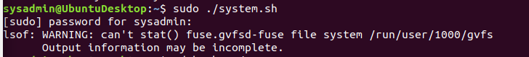

**cat ~/backups/diskuse/disk_usage.txt**



**Bonus**

* Command to copy system to system-wide cron directory:

**sudo cp system.sh /etc/cron.weekly**

### **Step 4. Manage Log File Sizes**

1. Run sudo nano /etc/logrotate.conf to edit the logrotate configuration file.  
     
    Configure a log rotation scheme that backs up authentication messages to the /var/log/auth.log.  
   * Add your config file edits below:

**/var/log/auth.log {**

**Weekly**

**rotate 7**

**Notifempty**

**Delaycompress**

**Missingok**

**endscript**

**}**

### **Bonus: Check for Policy and File Violations**

1. Command to verify auditd is active:

**sudo systemctl status auditd**

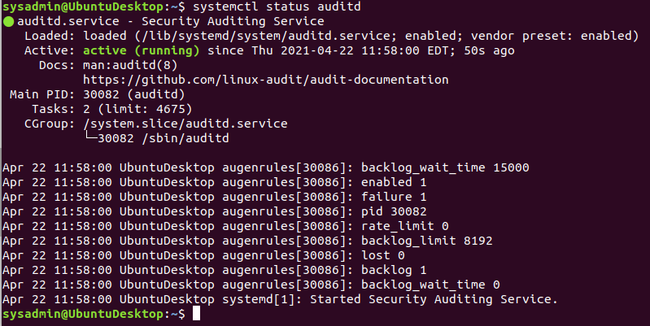

1. Command to set number of retained logs and maximum log file size:  
   * Add the edits made to the configuration file below:

**sudo nano /etc/audit/auditd.conf**

**max_log_file = 35**

**num_logs = 7**

1. Command using auditd to set rules for /etc/shadow, /etc/passwd and /var/log/auth.log:  
   * Add the edits made to the rules file below:

**sudo nano /etc/audit/rules.d/audit.rules**

**## For the permissions to monitor and set the keyname**

**-w /etc/shadow -p wra -k hashpass_audit**

**-w /etc/passwd -p wra -k userpass_audit**

**-w /var/log/auth.log -p wra -k authlog_audit**

1. Command to restart auditd:

**sudo systemctl restart auditd**

1. Command to list all auditd rules:

**sudo auditctl -l**  
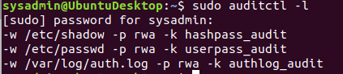

1. Command to produce an audit report:

**sudo aureport -au**  
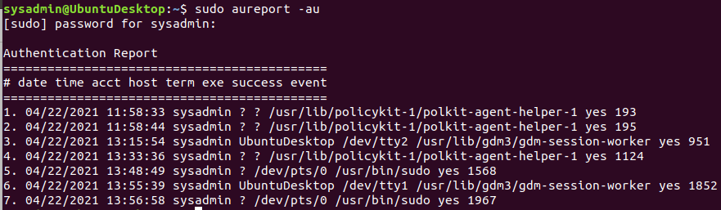

1. Create a user with sudo useradd attacker and produce an audit report that lists account modifications:

**sudo useradd attacker**

**sudo aureport -m**  
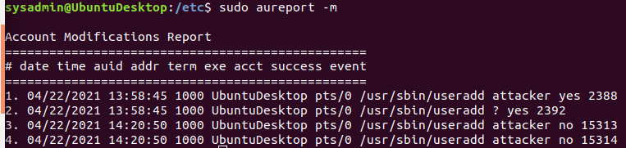

1. Command to use auditd to watch /var/log/cron:

**sudo auditctl -w /var/log/cron**

1. Command to verify auditd rules:

**sudo auditctl -l**

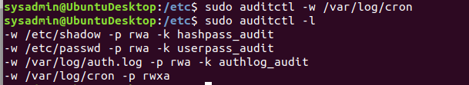

### **Bonus (Research Activity): Perform Various Log Filtering Techniques**

1. Command to return journalctl messages with priorities from emergency to error:  
   **sudo journalctl -b -p emerg..err**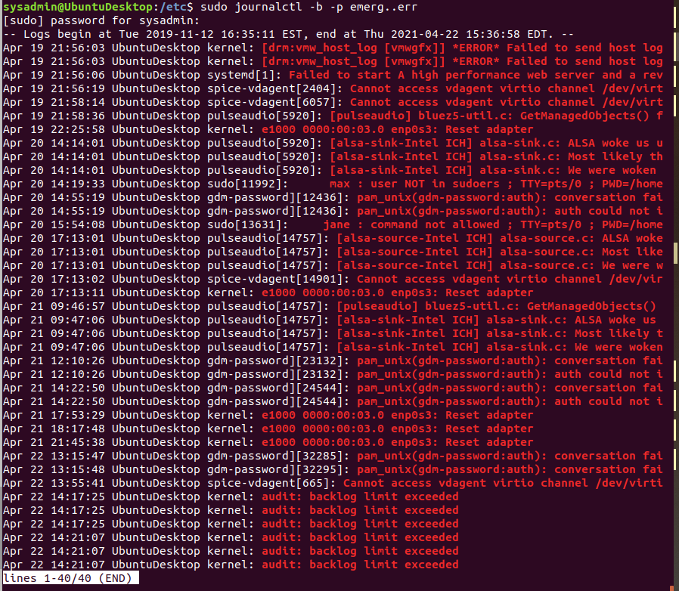
2. Command to check the disk usage of the system journal unit since the most recent boot:

**sudo journalctl -b -u systemd-journald | less**  
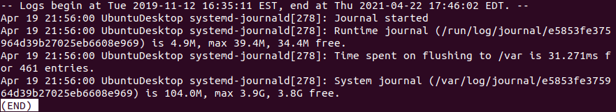

1. Command to remove all archived journal files except the most recent two:

**sudo journalctl --vacuum-files=2**  
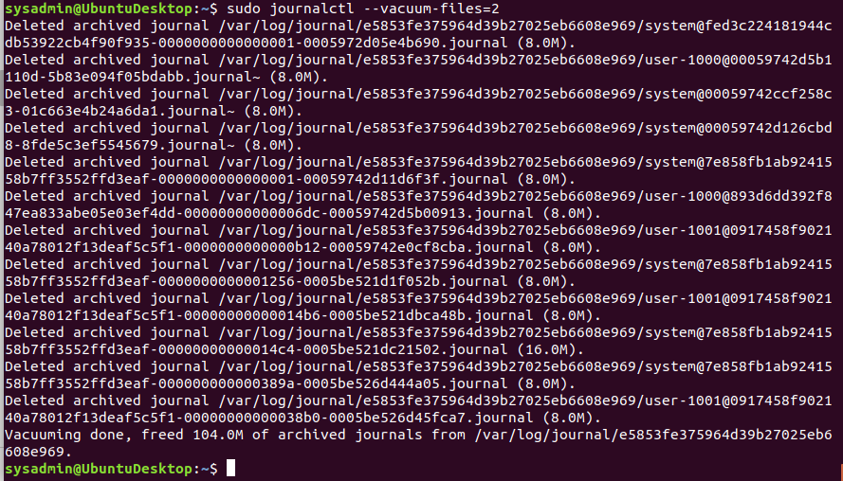

1. Command to filter all log messages with priority levels between zero and two, and save output to /home/sysadmin/Priority_High.txt:

**sudo su**

**cd ..**

**journalctl -p 0..2 > /home/student/Priority_High.txt**

1. Command to automate the last command in a daily cron job. Add the edits made to the crontab file below:

**sudo crontab -e**

**@daily journalctl -p 0..2 > /home/student/Priority_High.txt**

© 2020 Trilogy Education Services, a 2U, Inc. brand. All Rights Reserved.